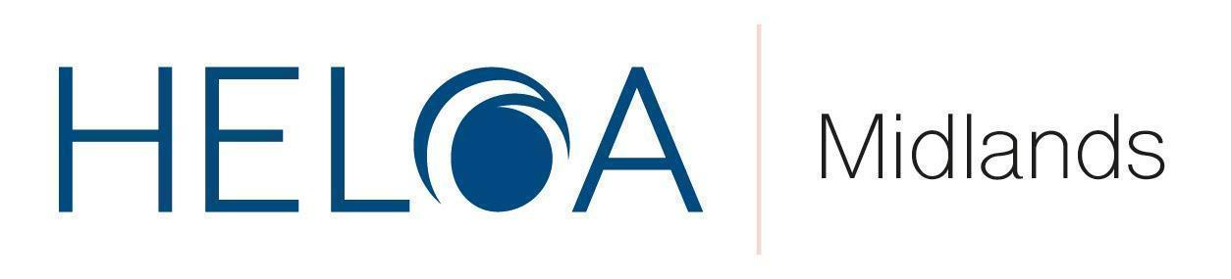

**HELOA Midlands Training Day Agenda**

**University of Northampton**

**Thursday 12th September 2024**

**Registered Charity numbers: 1182953 (England & Wales) and SC050285 (Scotland)**

**09:30 - 10.00am - Arrival with Welcome Refreshments - Sign in and Networking**

**10:00am - 10:20am - Welcome from committee, UKC updates and an introduction to the University of Northampton.**

**10:20am - 11:20pm - ‘Inspiring and Sustaining Positive Habits’ - Chris Burton - Executive Consultant and Facilitator (Charlotte Wiseman)**

Why are some habits so hard to start, and others so hard to break? Why do commitments to ourselves often fall to the bottom of our priority list when life gets busy? Why do we resist certain activities and habits, even when we know habits are good for us? Trying to cultivate positive change and establish new habits can be hard, and often setbacks can leave people feeling deflated, demotivated and disheartened.

**What You Will Learn:**

* Simple steps to create lasting positive change in our lives.
* A deeper self-awareness of the 'four tendencies' we align with, and how recognizing these tendencies can aid in developing new skills and improving our communication with others.
* 10 minute life hacks to fast track positive change.

**11:20am- 11:30am - Comfort break**

**11:30am - 12:30pm - Breakout Rooms:**

**Option 1: Queer to stay: Recognising LGBTQ+ students as WP target groups and interventions to support them- Kirsty McLaren - Senior Widening Participation Officer (Kings College London)**

According to Stonewall, LGBTQ+ students significantly more likely to: Be homeless, in care or estranged from their family; Underachieve in their Key Stage 5 academic attainment due to increased likelihood of truancy from bullying; Experience mental health problems before and during their undergrad; Experience physical and emotional abuse at the hands of a fellow student or university staff member; Be encouraged to hide who they are by members of university staff for an ‘easier life’. To me, these facts read clearly as a member of a ‘vulnerable group’. Universities and governing bodies must commit to supporting LGBTQ+ students in their Access and Participation Plans.

**What You Will Learn:**

* This workshop will explore research into LGBTQ+ identities at university, provide a safe space for all to ask questions and give opinions without judgement, and allow colleagues to collaborate in finding potential programmes or solutions to support the LGBTQ+ community.

**Option 2: UniTasterDays Update - Jon Cheek, UniTasterDays.com**

Jon will provide an update on current initiatives at UniTasterDays which members may be interested in getting involved in – including:

**What You Will Learn:**

* Upcoming opportunities to build your personal profile with schools for the new academic year.
* Upcoming opportunities to build your school and college teams' profiles with schools for the new academic year.
* Information about exciting new releases you can participate in, led by the new event incentive platform.
* Findings from the 2024 university guidance survey - and how the results compare to research from the last research UniTasterDays undertook back in 2018, about what schools want from universities and the barriers they may encounter.

**12.30pm- 12:45pm - Break and Refreshments**

**12:45pm - 13:30pm - Round Table Discussions - What Works for You?**

These will be interactive sessions involving thematic round table discussions. Members will have the opportunity to ‘bring to the table’ any key concerns, best practice and top tips, ideas and feedback for future Midlands sessions and anything else topical across the sector they would like to share / find out more on.

The session will last 30 minutes with 15 minute feedback to the entire group of the top themes discussed to ensure everyone gets to hear from all groups.

**Round Table options include (Choose on the day):**

* **Group A: Mentoring**. Delivered by a previous mentor & mentee on table to chat through their experiences, answer questions and how to get involved.
* **Group B: Ambassadors**. Jamie Leese (Applicant Services Officer at Staffordshire) will be on this table to offer help and advice with managing and training student ambassadors.
* **Group C: UCAS**. Rici Kreiger will be on hand to discuss topics, feedback and initiatives on all things UCAS - bring along your thoughts to be fed back to UCAS themselves.
* **Group D: Regional Reps.** Join Danny North and Lewis Clarke who will bring their experiences from different universities and various roles to share best practice and what works well, and not so well (!). Whether you are new to the sector or experienced, we will be encouraging the sharing of practice and how to get the most of the year ahead. Come with your questions / concerns / ideas!

**13:30pm - Closing Remarks & Finish**

**13:40pm - Optional lunch & tour of the University of Northampton (please state on the booking form if you are planning on staying for lunch).**

*All sessions are subject to change